*Florida International University*

*School of Computing and Information Sciences*

Software Engineering Focus

Feature Document

User Story ID #138

**Name:** Create Fellowship

**Team Member(s):** Winicius Siqueira, Alfredo Morales

**Project:** Fellowship Management 1.0

**Product Owner(s)**: Robert Zurita

**Mentor(s)**: Mohsen Taheri

**Instructor**: Masoud Sadjadi

**User Story Name: Create Fellowship**

* As an Admin User I would like to create a fellowship so that Fellow Users can view it and apply for it.

Acceptance Criteria

* An Admin User can create a fellowship. The fellowship will appear in the main page of the site.

**Use Case**

* Name: Create Fellowship
* Actor: Admin User
* Preconditions: The Admin User has logged in, navigated to the /admins/fellowships/ page, and clicked the “Add Fellowship” link.
* Description <Flow of events>: The Admin User fills out the form completely and clicks submit. If there are no errors, then the fellowship can be viewed in the home page. If there was an error, then the user is sent back to the form to correct the error.

**Use Case Diagram <**you can use draw.io**>**

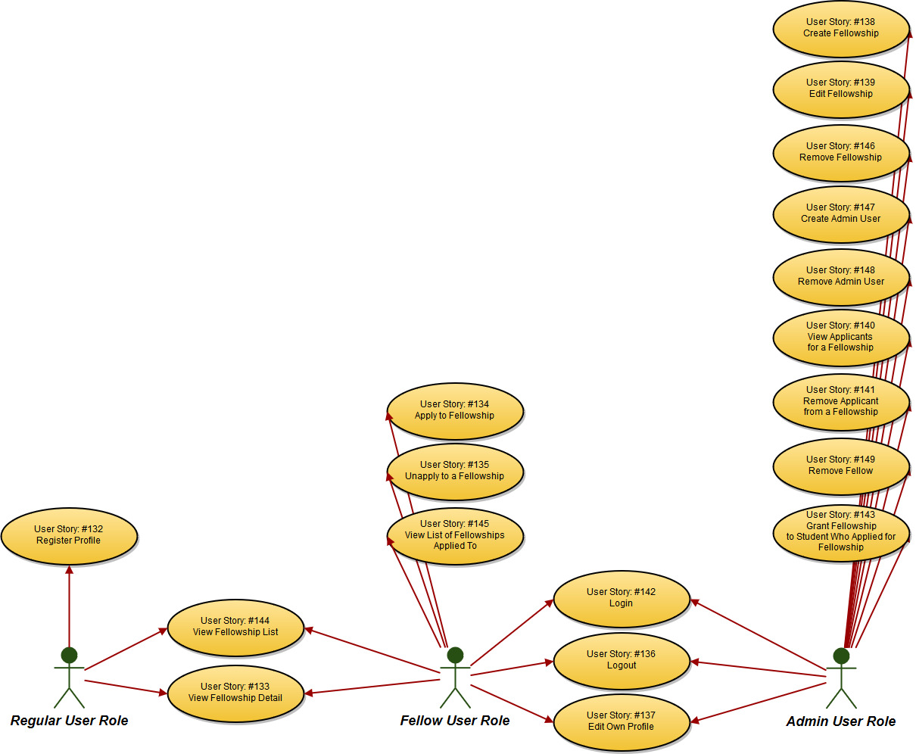

**Sequence Diagram**

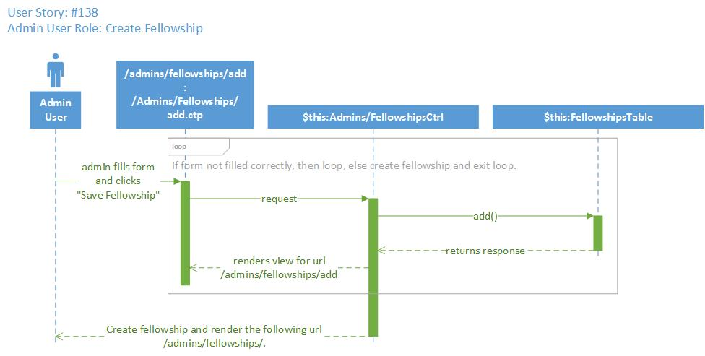

**Class Diagram**

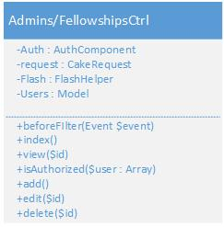

**Unit Test**

* Test case ID: testAddFellowshipPageLoadID138
* Description/Summary of Test: This test case checks that the following URL loads properly:

/admins/fellowships/add

* Pre-condition: The session variable contains id=1 and username=1.
* Expected Results: The following page loads properly: /admins/fellowships/add.
* Actual Result: The page loads properly.
* Status (Fail/Pass): Pass

**Integration Test**

**Visual User Guide** <like one or two screenshots of the feature. For the hardware project, a photo of device is required>

